# 2 Overall description

2.1 Product Perspective

The system is composed of:

1. A server that handles the requests from the mobile application
2. A data storage server used to store the needed data for the system to work properly
3. A web server that handles the requests from the web interface
4. An Internet interface used to link the system to the internet or dedicated network
5. Taxi drivers server that handles the taxi drivers requests
6. Mobile application interface: used to access the system services by an enabled mobile device
7. Web interface: used to access the system services by an enabled web browser
8. Taxi terminal: a device that sends to the system the taxi location and also acts at the driver’s system interface

Diagram of the system showing the different parts of the system and how they are connected

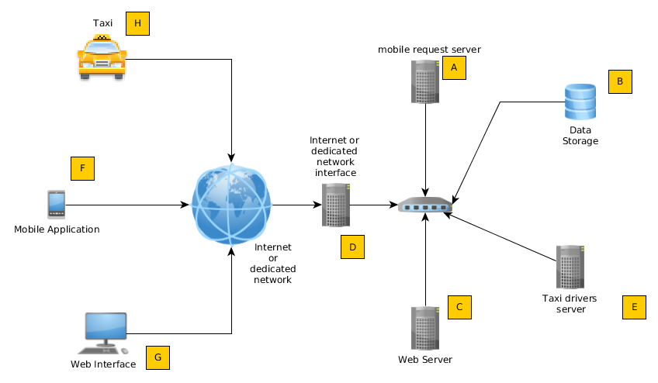

2.1.1 System interfaces

The system provides these interfaces:

1. Taxi driver interface that:
   1. Sends the current location of the taxi to the system
   2. Accepts the commands concerning the taxi driver normal operations
2. Mobile interface that:
   1. Enables the user registration to the service
   2. Enables the user authentication for the service access
   3. Allows the user to request a taxi for a ride
   4. Allows the user to reserve a taxi ride on a future date
   5. Allows the user to engage in a shared taxi ride
3. Web interface that:
   1. Enables the user registration to the service
   2. Enables the user authentication for the service access
   3. Allows the user to request a taxi for a ride
   4. Allows the user to reserve a taxi ride on a future date
   5. Allows the user to engage in a shared taxi ride
4. Internet or dedicated connection interface that:
   1. Establishes the link from the mobile and web interfaces to the respective servers
   2. Establishes the link from the taxi driver interfaces to the taxi drivers server

The system also provides a set of API to enable the expansion of the functionalities in the future

2.1.2 User interfaces

The mobile interface:

1. Must enable the user to insert string values and also, by using a map, to choose a location
2. Must notify of any error in a informative way, showing the user also a way to resolve the error
3. Any person with any school education level must be able use the mobile application services without any training

The web interface

1. Must be compliant with html 5 specification and be readable and usable in any standardized resolution
2. Must notify of any error in a informative way, showing the user also a way to resolve the error
3. Any person with any school education level must be able use the web interface services without any training

The Taxi driver interface:

1. To be able to use the driver’s specific services, the taxi driver’s interface must be easy to use also while driving (where highway code permits it) and while the taxi is still.
2. It must be able to send the position of the taxi to the system, manually or automatically
3. Any taxi driver must learn every function in at most 1 hour of training

2.1.5 Communication interfaces

In order to support the integration between the various parts of the system every protocol must use only standardized protocols to enable future modernization without compromising current operations

2.1.7 Operations

1. The application is always interactive, except for the operation of localization of the taxi
2. The backup of the data must be done daily with the risk of losing at most 24 hours

2.2 Product functions

User Registration

User Authentication

Request

Reservation

Initiate a Shared Ride

Add a shared ride passenger

Communication of the arrival and payment

2.3 User characteristics

Any technical expertise must not be necessary in order to access and use the mobile application and the web interface

Every person with a primary school education level must be able to execute every action concerning the use of the operations in the taxi service

The taxi drivers need to be instructed in order to be able to use their specific functionalities

2.4 Constraints

Any request, reservation, and shared ride cannot be performed by a non authenticated user

Any unauthorized person cannot use the taxi driver specific functions

Every taxi driver must be authenticated and authorized by the system administrator

The system must always respond to a user request (positively or negatively)

No downtime due to an internal system failure that is greater than 1% of the total time (of 1 year) is accepted

Only a downtime (due to an internal error) smaller than the 1% of the total amount of working hours is accepted

Two different users cannot simultaneously authenticate to the system with the same account

2.5 Assumptions and dependencies

The mobile application must be executed and tested on Android, IOS and Windows Phone platforms

The web interface must function correctly and be tested on any HTML 5 compliant browser

2.6 Apportioning of the requirements